**Applying for a Solidworks Sponsorship for FRC**

Go to <http://www.solidworks.com/sw/education/student-edition.htm>

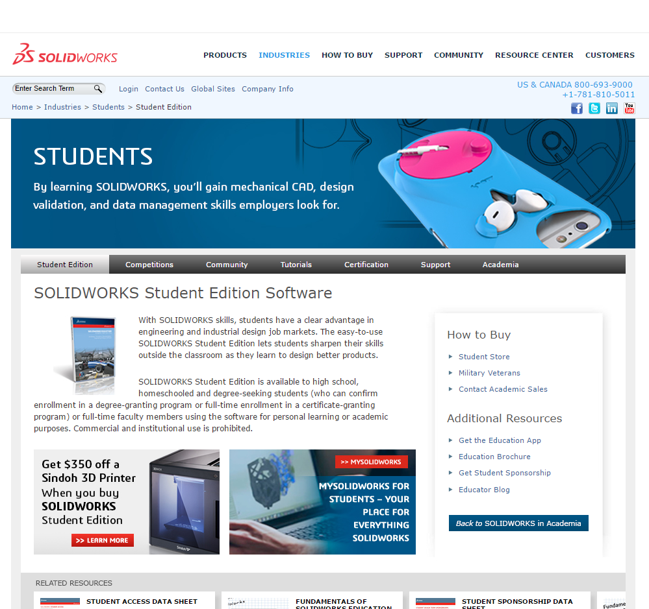

Click on *Get Student Sponsorship* on the right side of the page under Additional Resources.

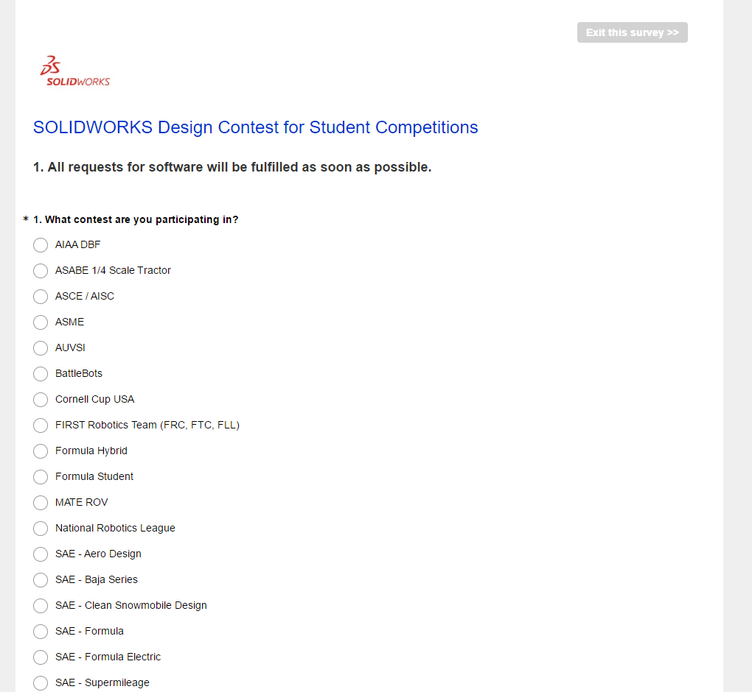

Fill out the survey beginning with selecting *FIRST Robotics Team*. When it comes time to state the number of students on your team, keep in mind that this number will be the number of licenses you will be awarded with your Solidworks Sponsorship, so if you plan on installing Solidworks on team computers as well as the students personal computers, you may want to increase this number.

Once the survey is submitted, you will receive an email (usually in 1-2 weeks) with a link to download and license codes for Solidworks. The license will typically last 2 FRC seasons before you will need to re-submit your sponsorship application